SUPPORT NETWORK FOR RURAL NEWCOMERS
MEETING #6

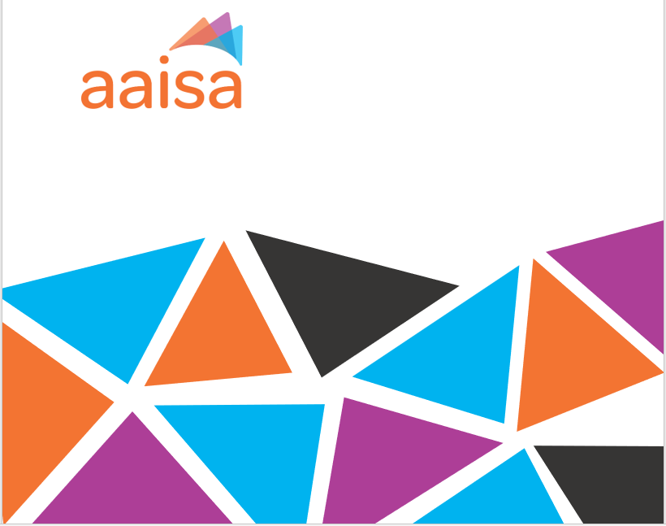
NOVEMBER 2023

Table Of Contents
Copyright Notice 1
LAND ACKNOWLEDGMENT 1
INTRODUCTION 2
COMMON CHALLENGES 2
RURAL RENEWAL STREAM 2
UPCOMING OPPORTUNITIES 3
IMMIGRATION, REFUGEES AND CITIZENSHIP CANADA: CALL FOR PROPOSALS 2024 (FUNDING FOR 2025-2030) 3
GOVERNMENT OF ALBERTA, SETTLEMENT, INTEGRATION AND LANGUAGE PROJECTS GRANTS 4
HOME SHARING APP 4
TOOLS FOR SUPPORT NETWORK PARTICIPANTS 4
NEXT STEPS 6

Copyright Notice
The content of this document is protected by Copyright © 2023 Alberta Association of Immigrant Serving Agencies (AAISA). All Rights Reserved. No part of this document including, but not limited to, the text, graphics, images, logos may be modified, reproduced, transmitted, distributed, publicly displayed or utilized for any commercial purpose, in any form, by any means, in whole or in part, without AAISA’s specific written permission. This Copyright Notice is an integral part of this document and shall not be removed or altered.

LAND ACKNOWLEDGMENT
AAISA acknowledges Treaty 7 territory—the traditional and ancestral territory of the Blackfoot Confederacy: Kainai, Piikani and Siksika as well as the Tsuu T’ina Nation and Stoney Nakoda First Nation. We acknowledge that this territory is home to the Métis Nation of Alberta, Region 3 within the historical Northwest Métis Homeland. We acknowledge the many First Nations, Métis and Inuit who have lived in and cared for these lands for generations. We are grateful for the traditional Knowledge Keepers and Elders who are still with us today and those who have gone before us. We make this acknowledgement as an act of reconciliation and gratitude to those whose territory we reside on or are visiting.

INTRODUCTION
This sixth Support Network for Rural Newcomers to Alberta meeting was held on November 16, 2023. This meeting introduced the upcoming Rural Renewal Backgrounder and a Promising Practices Report, a white paper that overviews the Rural Renewal Stream in Alberta, outlining challenges and opportunities that service providers, municipalities, and community-based agencies face in participation with the stream.
As the second last meeting of this engagement initiative, AAISA received feedback from participants that on-going, quarterly meetings would be beneficial to maintain the momentum of these informal partnerships with new participants continuing to join the Support Network. With this positive feedback, AAISA is examining internal capacity to continue hosting quarterly meetings for the Support Network, enabling rural settlement workers, community service providers, and municipal agents to share challenges, collaborate and co-create best practices to serve newcomers.
COMMON CHALLENGES

RURAL RENEWAL STREAM
Employment Misconceptions
Several participants continued to share concerns regarding advising newcomers about realistic employment opportunities and expressing the need to correct misconceptions about the municipal role in obtaining permanent residency. Employers seeking newcomer labour, are often hiring for low wage jobs that make it challenging for newcomers who must meet the high language and professional skill requirements to apply for permanent residency to find suitable. The gap between skills, experience, and language qualifications with short-term, vulnerable, low wage labour makes retention challenging in rural communities.
Vulnerable Persons Open Work Permit
There have been several newcomers who have had to apply for a Vulnerable Persons Open Work permit. This permit is specific to migrant workers on employer-specific work permits who are experiencing abuse, or who are at risk of abuse. This permit allows migrant workers with a means to leave their employer without risking their status in Canada. This highlights a larger trend between employers in Canada relying on newcomers as a foundational labour force for precarious industries.
High requirements for language skills and education equivalencies
Newcomers seeking to participate in the Rural Renewal Stream are struggling to meet the high language requirements of the program. To receive permanent residency, newcomer applicants must meet Canadian Language Benchmark level 9+. The Canadian Language Benchmarks (CLB) International English Language Testing System Examination (IELTS) comprises of levels 0-12. CLB 9 is equivalent to Initial Advanced English proficiency, with CLB 4 equating to Fluent Basic.
Newcomers continue to face the barrier of having their international education recognized as Canadian equivalencies. Several Support Network participants have observed that newcomers are being required to take high school equivalency courses such as Biology 30 or Math 20 instead of a standardized assessment to evaluate their international education.
Limited Housing Availability
Newcomers entering rural regions continue to face on-going challenges with limited housing availability. A Support Network participant shared that a local church organization provided financial support for a newcomer family whilst waiting for restrictions associated with temporary visas to permit the individual to work freely. The local church initially budgeted to support the newcomer family for nearly double their original anticipated timeline (from 2-3 months to 5 months). There has been at least one community in the Support Network interested in finding more long-term housing strategies for newcomers to prevent future incidents like this from occurring.
UPCOMING OPPORTUNITIES
AAISA has identified areas of opportunities and collected resources for Support Network participants to expand their capacity to serve newcomers in rural regions.

IMMIGRATION, REFUGEES AND CITIZENSHIP CANADA: CALL FOR PROPOSALS 2024 (FUNDING FOR 2025-2030)
Immigration, Refugees and Citizenship Canada (IRCC) has released the Call for Proposals (CFP) 2024. This CFP closes on January 31, 2024, for funding to begin April 1, 2025 and can last up to five years, ending March 31, 20230. This iteration of the CFP reveals opportunities for municipalities to apply for settlement funding. Services that municipalities are eligible to apply for include:
- ⁠Service delivery improvement
- Resettlement Assistance Program (RAP)
- Indirect Services with a Community or Local Focus
- SWIS
- Community connections
- Support services
- Employment-related services
- Language assessment and training services
- Information and orientation services
- Case management
- Needs and assets assessment and referral services (NARS)
- Pre-arrival

Applicants are permitted to apply to more than one funding opportunity. IRCC is also hosting information webinars open to all interested applicants. The full schedule and registration can be found here.

GOVERNMENT OF ALBERTA, SETTLEMENT, INTEGRATION AND LANGUAGE PROJECTS GRANTS
The Government of Alberta has opened the application portal for the Settlement, Integration and Language Projects. This application’s information call is due on January 10, 2024, with the full application due on January 26, 2024, and will provide funding that starts as late as March 31, 2024, and can last up to 24 months.
This grant funds the Support Network project through the Building Community Capacity Stream. This stream is eligible for municipalities, non-profit organizations, and economic development organizations to apply for.
For more information, please see the Government of Alberta website here.
HOME SHARING APP
The town of Drumheller has been actively spearheading strategies to combat the housing crisis that Canadians are facing. Outlined in their Housing Strategy are 29 actions to be taking place over the course of the next 10 years. Partnerships were developed with Community Futures, Travel, and the Chamber of Commerce to receive a grant funding a Home Sharing Application. This app is being developed to match people according to their personalities, hobbies, and interests to assist with seasonal influxes of Drumheller tenants.
TOOLS FOR SUPPORT NETWORK PARTICIPANTS
Newcomer Welcome Package Template
AAISA has finished the Newcomer Welcome Package template for the Support Network participants and encourages everyone to use the template and customize it to their municipality’s unique programs and services available. The Newcomer Welcome Package template can be downloaded from this link. The template is comprehensive, providing information about immigration streams, basic needs for the first 14 days of arrival, housing information, newcomer services, community services, healthcare services, employment opportunities and more.
Tools to Engage Landlords and Employers
One of the significant challenges faced by settlement workers and community partners dedicated to helping newcomers settle in rural areas is the engagement with local landlords and employers. Frequently, there is a lack of awareness about the systemic barriers newcomers face when seeking housing and employment. To address this issue, creating engagement tools and informative documents for landlords and employers becomes essential to encourage better integration for newcomers in their communities.
Guided by the needs of the Support Network participants, and developed through partnerships with our existing professional networks, AAISA has developed Creating a Welcoming Workplace: A Guide for Employers with Newcomer Employees. This guide delves into the unique challenges faced by newcomers, providing valuable insights and actionable strategies. From understanding newcomer perspectives and overcoming language barriers to cultivating cultural sensitivity and promoting employer responsiveness, this guide equips you to play a vital role in the successful integration of newcomers into your community. Elevate your workforce, contribute to your local economic prosperity, and create a workplace where everyone feels welcome.
The tool can be found on our toolkit, here.
Professional Development Courses
AAISA has produced and delivered 5 professional development courses to meet the needs of Support Network participants. The courses and descriptions can be found in Table 1. These courses were live facilitated but will be converted to a self-paced version in 2024. The self-paced, asynchronous version of the courses are designed to meet the timeline constraints of Support Network participants who may not have had the flexibility in scheduling to attend the live sessions.
Table 1. Professional Development courses created and delivered by AAISA for the Support Network Participants, focused on rural strategies.
Course Name | Course Description
Strengthening Rural Capacity to Support Newcomers | This course explores existing programs/practices and up-to-date resources that have proven effective at supporting newcomers or intersecting identities, the difficulties and challenges in accessing these services and how access can be improved particularly in rural communities. It will describe principles of a trauma-and-violence informed framework and apply concepts of Culturally Responsive trauma-and-violence informed care to settlement practice. It will prepare learners to provide employment-related services to newcomers by understanding the challenges that impact migrant communities in the areas of employment and reviewing innovative practices particularly for immigrants with severe language/literacy barriers. It is intended to build knowledge of the complex intersecting issues experiences the newcomer settlers in rural communities and address the multiple needs of newcomer populations experiencing multiple barriers.
Immigration: Processes & Mechanics | This course is aimed at introducing the Canadian Immigration System, review Canadian immigration history, immigration policies and trends. It will focus on discussing current issues related to immigration, it’s impact on newcomers, and address the ways to overcome those challenges. Additionally, it will describe immigrants’ categories and streams, ways to review the application process for key immigration streams, including supporting applicants at all stages of the application procedures.
Outreach and Community Connections | This course aims to provide practical insights, knowledge, and skills to settlement workers and individuals supporting newcomers and refugees. The course content will focus on enhancing rural outreach and community connections and familiarize the participants about various strategies for making effective connections.
Exploring Funding Opportunities for Rural & Small Centres | This course is focused on exploring the funding landscape, different types of funding opportunities available, and how to effectively and efficiently find grants that fit organizational goals and objectives. This course teaches how to write effective grant proposals and applications, including project plans, needs statements, budgets, anticipated outcomes and deliverables, as well as how to utilize and implement logic models. This course helps the learner understand the criteria that funders use to evaluate grant proposals, including how to tailor proposals appropriately. This course promotes strategies to building relationships with funders, and how to manage and report on grant-funded programs.
Understanding the Settlement Sector & Services | Canada is a global pioneer in settlement services for its immigrant community, which are supported and delivered by the government. The provision of such services is regarded as a crucial component in assisting immigrants to integrate and settle in Canada more successfully. This webinar provides a comprehensive understanding of the settlement sector.

NEXT STEPS
AAISA is preparing to host a Local and Zonal Immigration Partnerships (LIP/ZIP) panel event in 2024 to introduce Support Network participants to LIP/ZIPs in rural Alberta, highlight the benefits of joining a LIP/ZIP, as well as explore opportunities for forming informal partnerships between LIP/ZIPs and Support Network participants to increase the settlement and integration outcomes of newcomers to rural Alberta.
The next Support Network meeting will be held on January 11, 2024.

https://www.canada.ca/en/immigration-refugees-citizenship/corporate/publications-manuals/operational-bulletins-manuals/temporary-residents/foreign-workers/vulnerable-workers.html

